A PROJECT REPORT ON

**GROCERY MANAGEMENT SYSTEM**

SUBMITTED TO

THE UNIVERSITY OF PUNE

**IN PARTIAL FULFILMENT OF THE REQUIRMENT**

**FOR M.Sc (COMPUTER SCI.) SEMESTER IV.**

SUBMITTED BY:

**SHAIKH MUSKAN NASHIR (9260)**

UNDER THE GUIDANCE OF

**Ms.Shaheda Ansari**

**Dr .Mahtab Alam**

DEPARTMENT OF COMPUTER SCIENCE

AKI’S

POONA COLLEGE OF ARTS SCIENCE & COMMERCE

CAMP, PUNE

[2020-21]

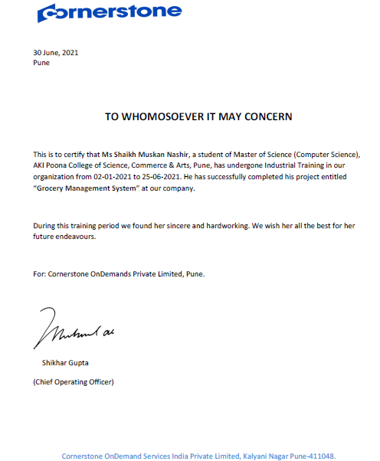

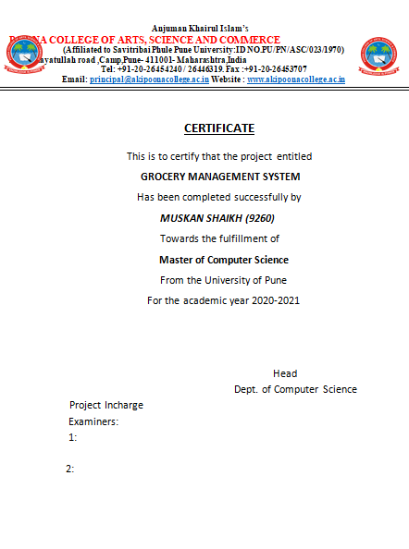

**INDEX**

|  |  |  |
| --- | --- | --- |
| **Sr.no** | **Topic** | **Page No** |
| 1. | Introduction | 5 |
| 1.1 | Project Statement | 6 |
| 1.2. | Objective of the system | 7 |
| 1.3 | Literature Survey | 8-9 |
| 1.4 | Project Scope And Limitation | 10 |
| 2. | System Analysis | 7-8 |
| 2.1 | Study of the Existing System | 9 |
| 2.2 | Scope of the Existing System | 10 |
| 2.3 | Project Perspective, Features | 11 |
| 2.4 | Stackholders | 12-26 |
| 2.5 | Requirement Analysis | 12 |
| 3. | System Design | 13 |
| 3.1 | Design Constrains | 14 |
| 3.2 | UML Diagram | 15-17 |
| 3.2 | Data Model | 18 |
| 3.4 | User Interface | 19-21 |
| 4 | Implementation Details |  |
| 4.1 | Software/Hardware Specification | 22-24 |
| 5. | Report | 25 |
| 6. | Testing | 26 |
| 7. | Conclusion | 27-28 |
| 8. | Future Scope | 29-31 |
| 9. | Bibiliography | 32-51 |
| 10. | Report | 52-54 |

**INTRODUCTION**

* A Grocery store is a retail stored that primarily sells food.
* A Grocer is a bulk seller of food.
* As pollution around the word has increased buying food on the road side is not advisable.
* Whether is charge of a sum
* All individually owned grocery stored or one that is part of larger chain maintaining a grocery stored successfully involve considerable responsibility.
* There are a lot of successful websites such as BigBasket.com, askmegrocery.com etc. in this space.
* Purpose of Online Grocery Management system is to allow customer to shop virtually using internet.
* Computerization of online store will increase the ease, efficiency and reduce the chances of manual errors.

.

**Problem Definition**

We are going to build a software restaurant automation system that will have several features such as:

* Stock management
* Internet online reservation
* Online ordering via network enabled handheld computer
* Customer management
* Accounting
* Executive information system

In addition to those features, we are planning to add

* Statistical data about sales using graphics
* Customer profile (customer name, address, preferences, etc.)

**OBJECTIVE OF THE SYSTEM**

The system requires very low system resources and the system will work on almost all configurations. The aim of purposed system is to develop a system of improved facilities. The proposed system can overcome all the limitations of the existing system. The system provides proper security and reduces the manual work.

* Ensure data accuracy’s.
* Proper control of the higher officials.
* Minimum time needed for the various processing
* Greater efficiency.
* Better service.
* User friendliness and interactive.
* Minimum time required.

**LITERATURE SURVEY**

After doing the project Online Grocery Management System, study and analysing all the existing or required functionalities of the system, the next task is to do the feasibility study for the project. All projects are feasible given unlimited resources and infinite time.

Feasibility study includes consideration of all the possible way to provide a solution to the given problem. The Proposed solution should satisfy the entire user requirement and should be flexible enough so that future change can be easily done based on the future upcoming requirement.

**1: Economical Feasibility**

This is very important aspect to be considered while developing a project. We decide the technology based on minimum possible cost factor.

* All hardware and software cost have to be borne by the organization.
* Overall, We have estimate that the benefits the organization is going to receive from the proposed system will surely overcome the initial costs and the later on running.

**2: Technical Feasibility**

This includes the study of function, performance and constraints that may affect the ability to achieve an acceptable system. For this feasibility study, We studied complete functionality to be provided in the system, as described in the system requirement specification (SRS), checked if everything was possible using different type of frontend and backend platform.

**3: Operational Feasibility**

No doubt the proposed system is fully GUI based that is very user friendly and all inputs to be taken all self-explanatory even to a layman. Besides, a proper training has been conducted to be let know the essence of the system to the users so that they feel comfortable with new system. As far our study is concerned the clients are comfortable and happy as the system has cut down their loads and doing.

**PROJECT SCOPE AND LIMITATIONS**

* The Online Grocery Management System is to manage the details of Grocery, Delivery Address, Order Grocery.
* The purpose of project is to build an application program to reduce the manual work for managing the grocery system.
* To satisfies the user requirement.
* The system generates types of information that can be used for various purpose.
* Have a good user Interface.
* Be expandable.
* Delivery on schedule within the budget.

**LIMITATIONS:**

* In manual system reports, documentation takes lot of time that causes daily in the processing.
* Large value of transaction of data cannot be handle efficiently.
* It is not easy to maintain records with register for long period.
* Security is not provided.
* There were many functions that demanded computerization, but there were not begin covered by the manual system.

**EXISTING SYSTEM**

In the existing system the exam are done manually but in proposed system we have to computerize the exam using this application.

**LIMITATION OF EXISTING SYSTEM:**

* Lack of security of data.
* More man power.
* Time consuming.
* Consumes large volume of paper work.
* Needs manual calculations.
* No direct role for the higher officials.
* To overcome all these limitations the system needs to be computerized.

**PROJECT PERSPECTIVE, FEATURES**

* The system is user-friendly and has simple interface
* Can be used in manufacturing company.
* It is the process of detecting the name of any colour and its value.

**Stackholders:**

Admin

Customer

Employee

**REQUIREMENT ANYALYSIS**

Requirementanalysis identifies, analyze, and model the functionality. Requirement analysis is the process of defining user expectations for new software being built or modified.

* **Functional requirements:**

A functional requirement is simply a task sometimes called as action or activities that must be accomplished to provide operational capabilities

In this there will be some function used for loading image,etc.

* **performance requirements**

A Performance requirements is a statement of the extent to which a function must be executed, generally measured in terms such as quantity, accuracy, coverage, timelines, or redlines. Performance of this project is very good. The accuracy of this project is hundred percent. It gives correct color name

* **security requirements:**

Security requirement describe functional behavior that enforce security. Functional requirement can be directly tested and observed.

**DESIGN CONSTRAIN:**

Design constraints are conditions that need to happen for a project to be successful. Design constraints help narrow choices when creating a project. Design constraints can feel like a negative things sometimes, but they help shape the project to fit the exact needs of the client.This system provide security. The login form prevents the system form being missing used by unauthorized users. Only an authorized operator granted rights to modify as per requirement. This software is reliable and fault tolerance. The system develop is design to handle invalid input. The user should know the programming Language very well that is used to developed a software. Every project manager knew the project constrain in a project managements:

* Time: What the deadlines for delivering the output? How much time required completing the project system?
* Scope: what exactly is the expected outcome? That means it will complete the customer requirements.
* Cost: How much money is available to achieve this outcome?

**UML DIAGRAMS**

**Class Diagram:**

In software engineering, a class diagram in the Unified Modelling Language(UML) is A type of static structure diagram that describes the structure of a system by Showing the system's classes, their attributes, operations(or methods), and the Relationships among objects. Class diagrams show the actual classifiers and their

Relationships in a system

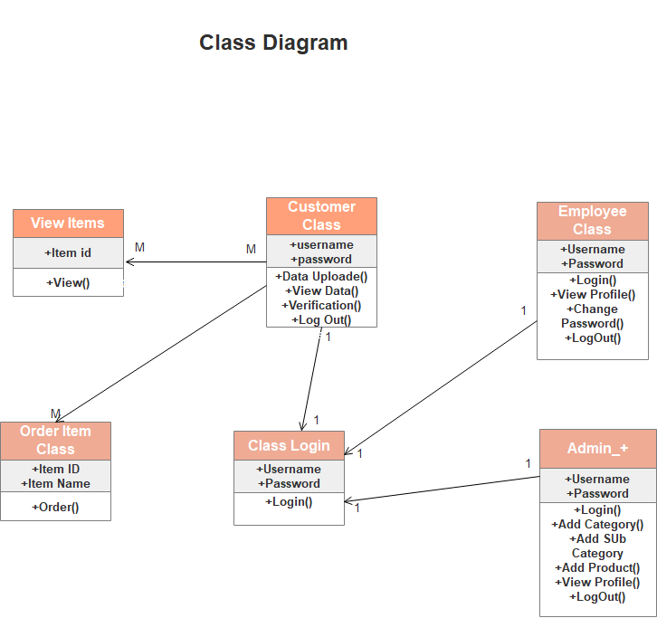

**Object Diagram:**

Object diagrams are derived from class diagrams so object diagrams are dependent upon class diagrams. Object diagrams represent an instance of a class diagram. The basic concepts are similar for class diagrams and object diagrams. Object diagrams also represent the static view of a system but this static view is a snapshot of the system at a particular moment. Object diagrams are used to render a set of objects and the relationships as an instance.

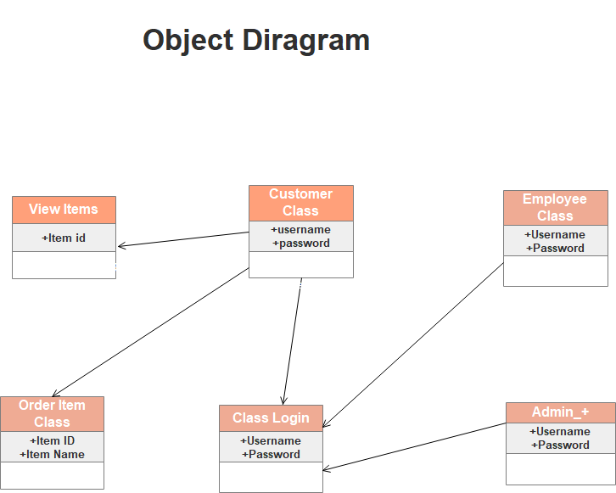

**Sequence Diagram:**

Sequence diagrams describe interactions among classes in terms of an exchange of messages overtime. They’re also called event diagrams. A sequence diagram is a good way to visualize and validate various runtime scenarios. These can help to predict how a system will behave and to discover responsibilities a class may need to have in the process of modelling and system. A sequence diagram simply

depicts interaction between objects in a sequential order. The ordering which these interactions take place. We can also use the terms event diagrams or event scenarios to refer to a sequence diagram.

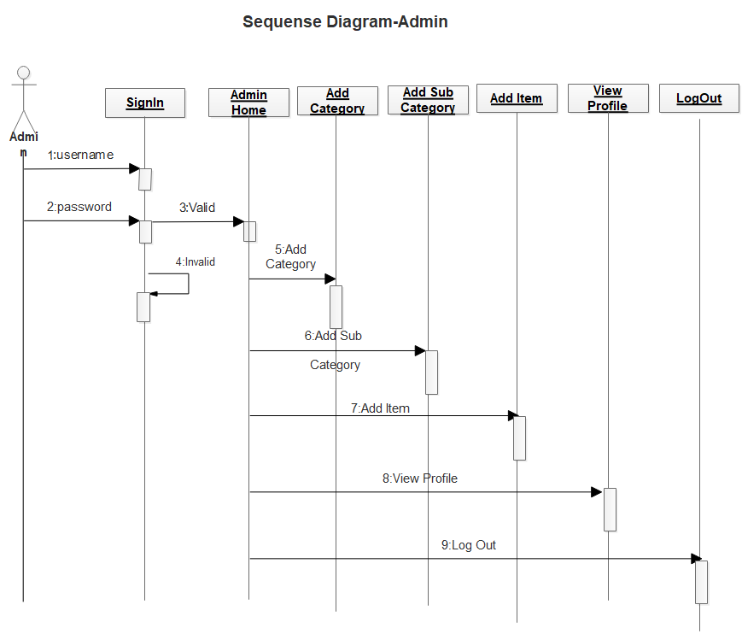

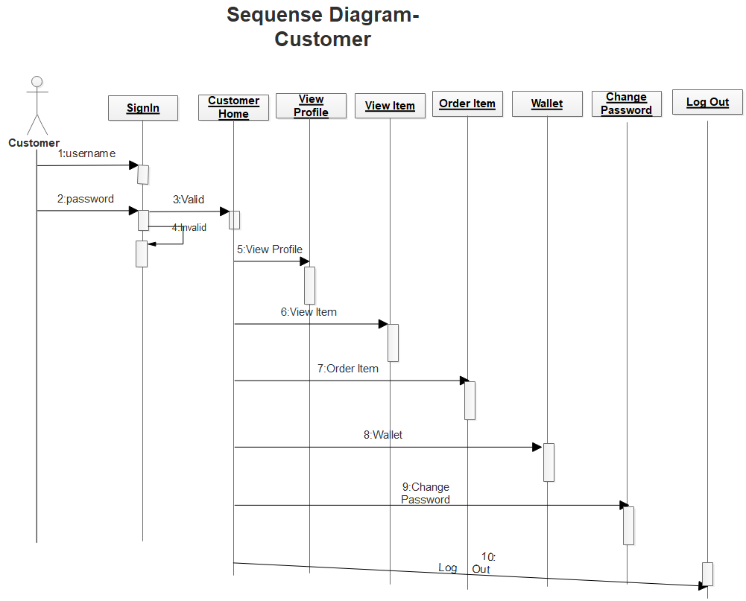

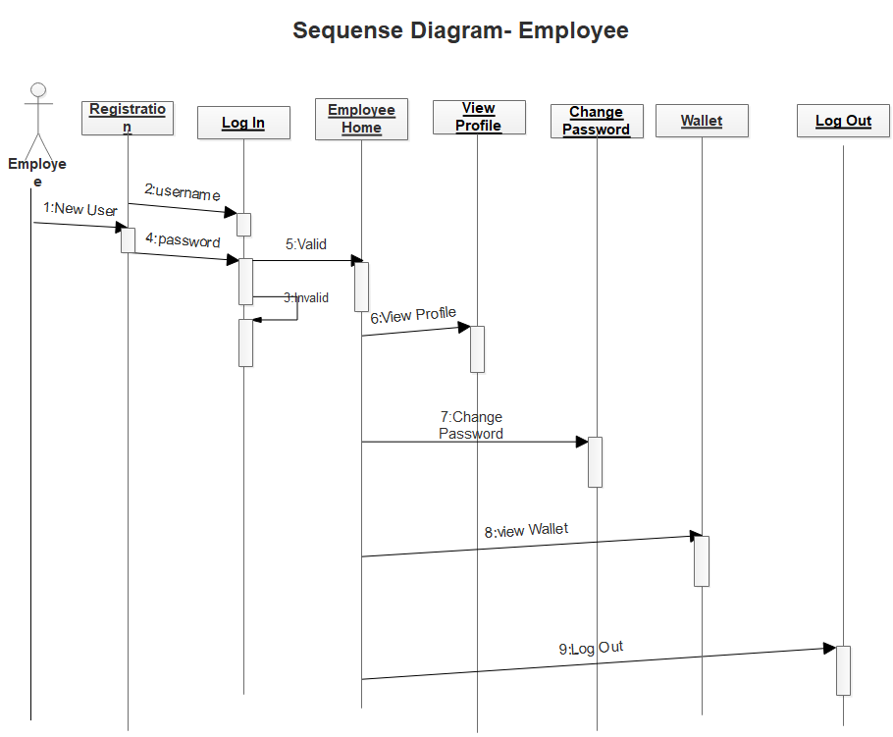

**Activity Diagram:**

We use Activity Diagrams to illustrate the flow of control in a system and refer to the steps involved in the execution of a use case. An activity diagram is a behavioural diagram i.e. it depicts the behaviour of a system. An activity diagram portrays the control flow from a

start point to a finish point showing the various decision paths that exist while the activity is being executed.

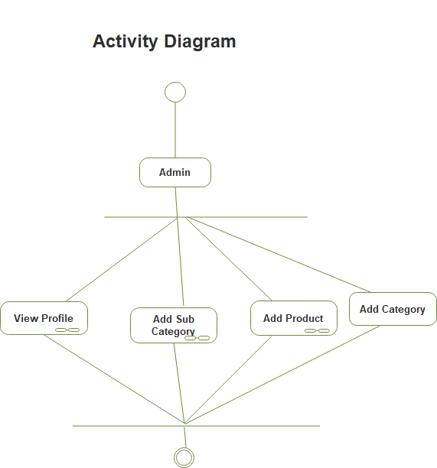

**Collaboration Diagram:**

A collaboration diagram, also known as a communication diagram, is an illustration of the relationships and interactions among software objects in the Unified modelling Language(UML). These diagrams can be used to portray the dynamic behaviour of a particular usecase and define the role of each object

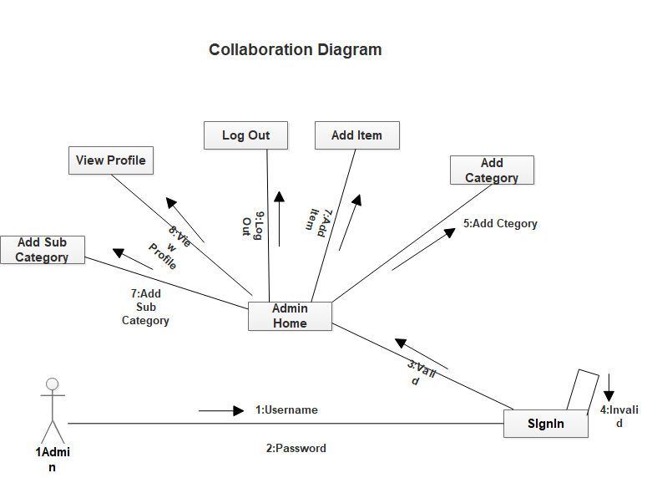

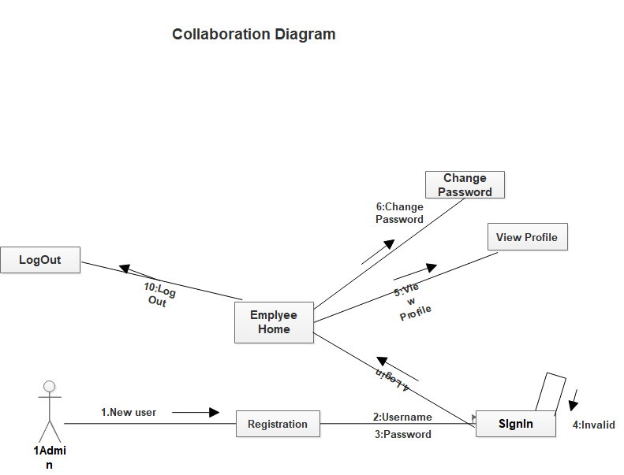

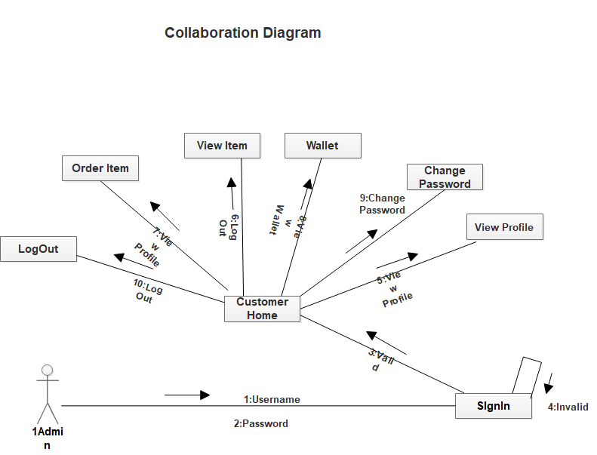

**Components Diagram:**

A component diagram also known as a UML component diagram, describe the Organization and wiring of the physical components in a system. Component diagrams are often drawn to help model implementation details and double-check that every aspect of the system's required functions is covered by planned development

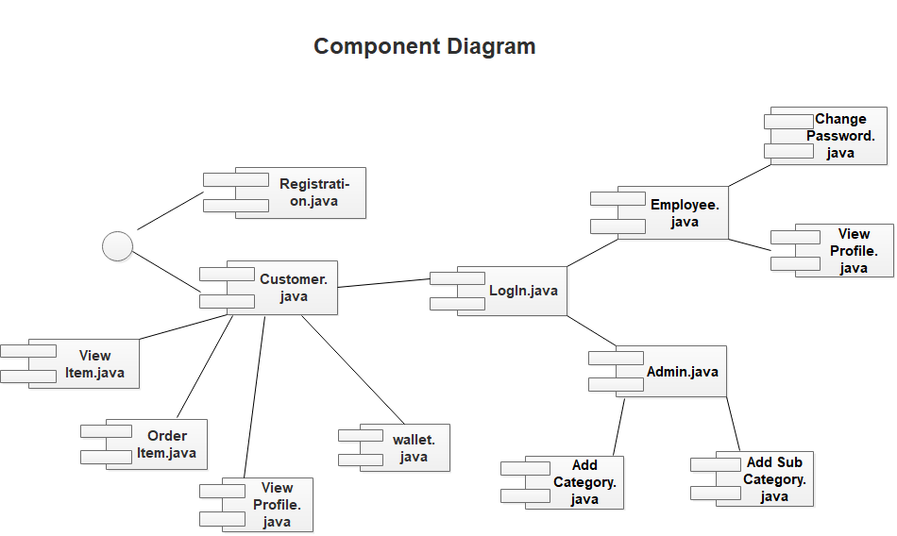

**Deployment Diagram:**

Deployment diagrams are used to visualize the topology of the physical components of a system, where the software components are deployed. Deployment diagrams are used to describe the static deployment view of a system. Deployment diagrams consist of nodes and their relationships

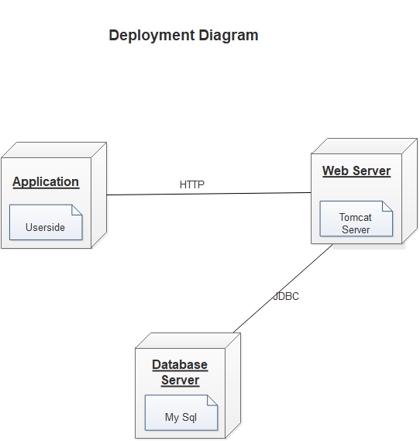

**State Transition Diagram**:

A state diagram is used to represent the condition of the system or part of the system at finite instances of time. It’s a behavioural diagram and it represents the Behaviour using finite state transitions. State diagrams are also referred to as State machines and State-chart Diagrams. These terms are often used interchangeably. So simply, a state diagram is used to model the dynamic behaviour of a class in

Response to time and changing external stimuli .We can say that each and every class has a state but we don’t model every class using State diagrams*.*

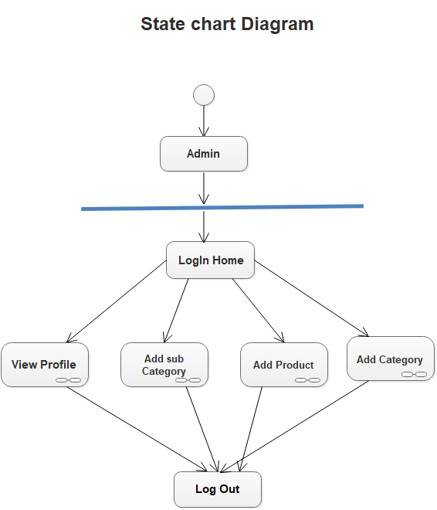

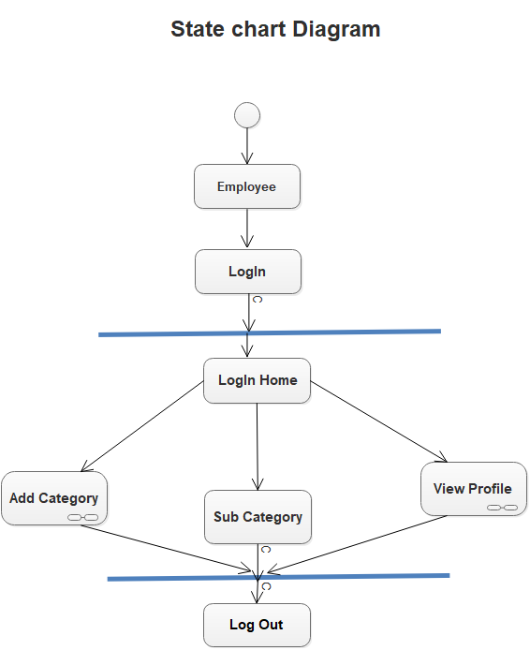

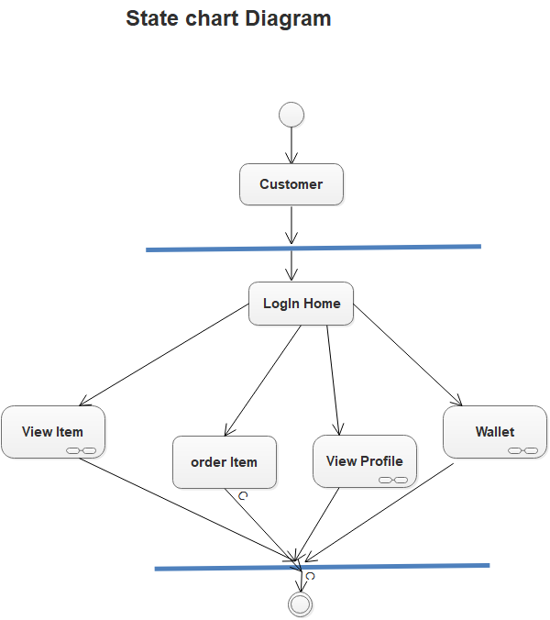

**Use-Case Diagram:**

A use case diagram is a dynamic or behaviour diagram in UML. Use case diagrams model the functionality of a system using actors and use cases. Use cases are as to factions, services, and functions that the system needs to perform....The “actors" are people or entities operating under defined roles within the system.

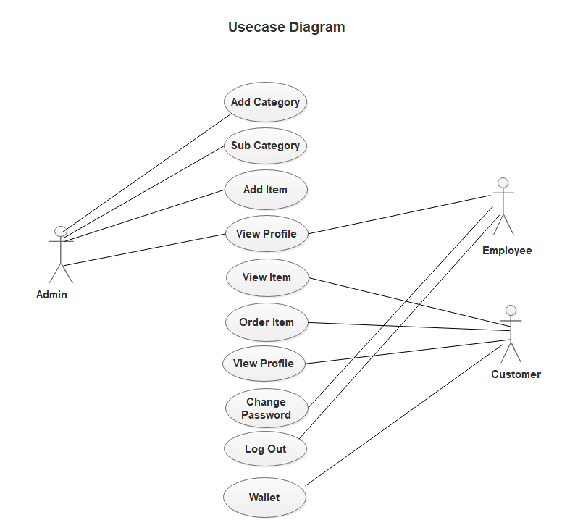

**User Interface**

**WELCOME FORM:**

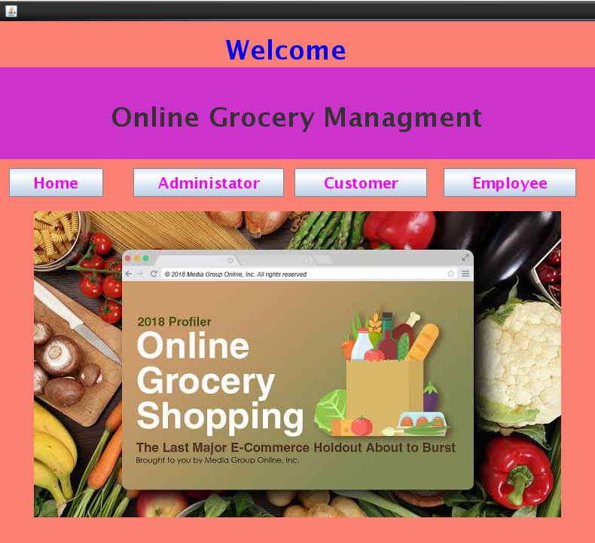

**ADMIN LOGIN:**

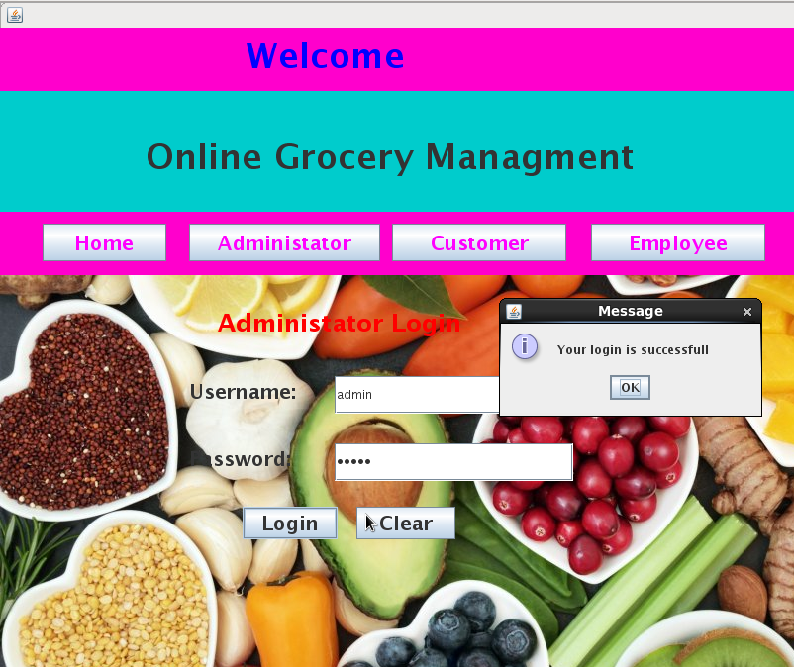

**CUSTOMER LOGIN:**

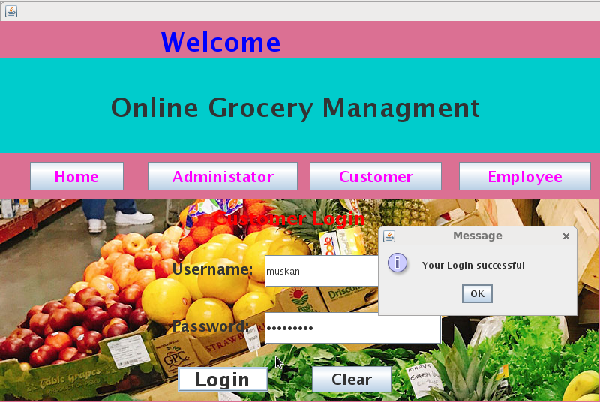

**Employee Login:**

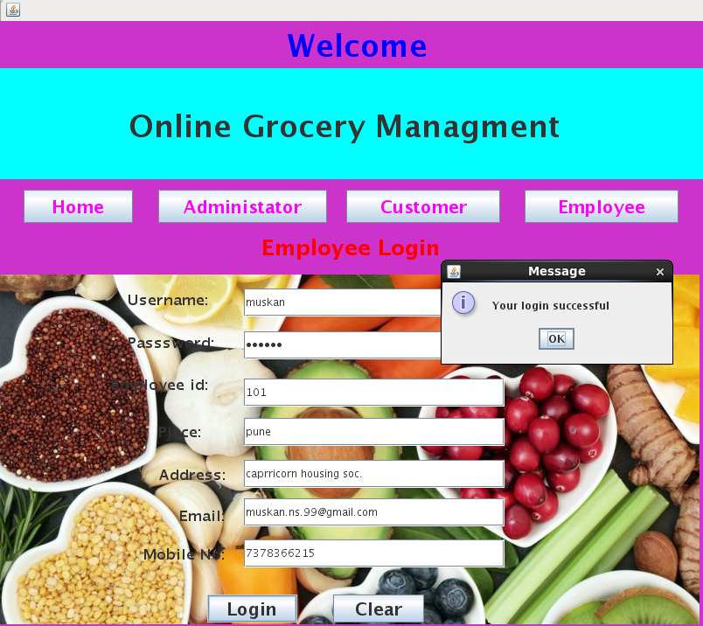

**Firstpage:**

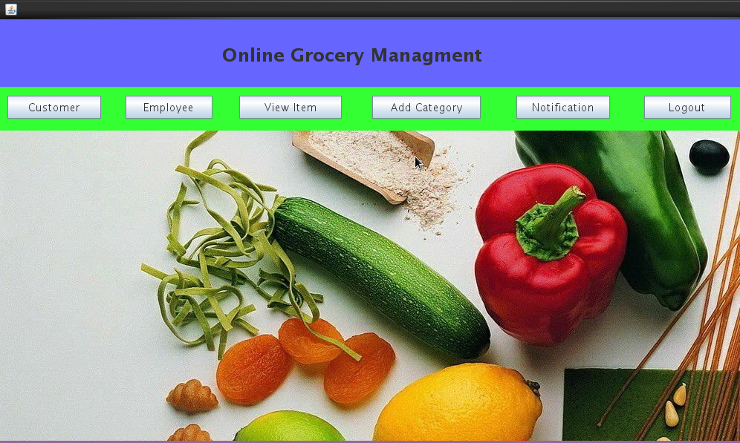

**CUSTOMER DETAILS:**

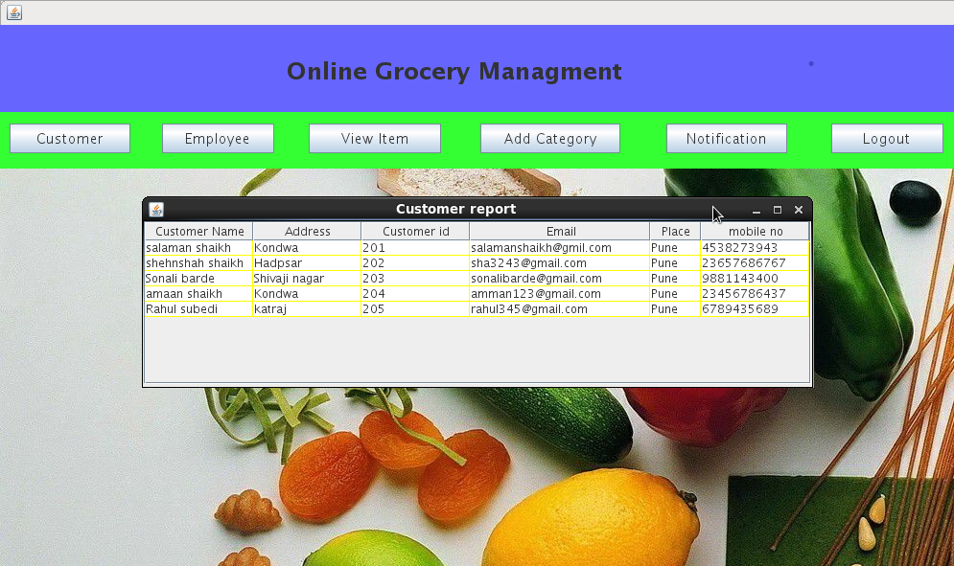

**EMPLOYEE DETAILS:**

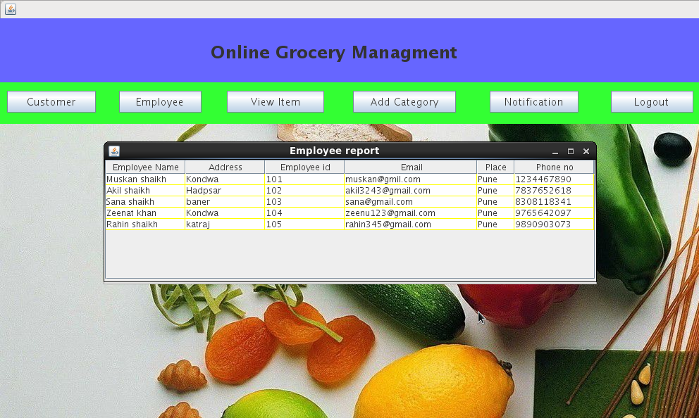

**View Item:**

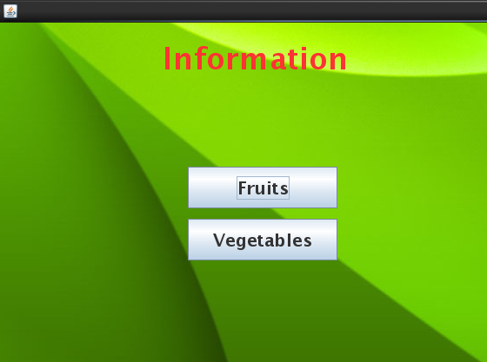

**Fruits Information:**

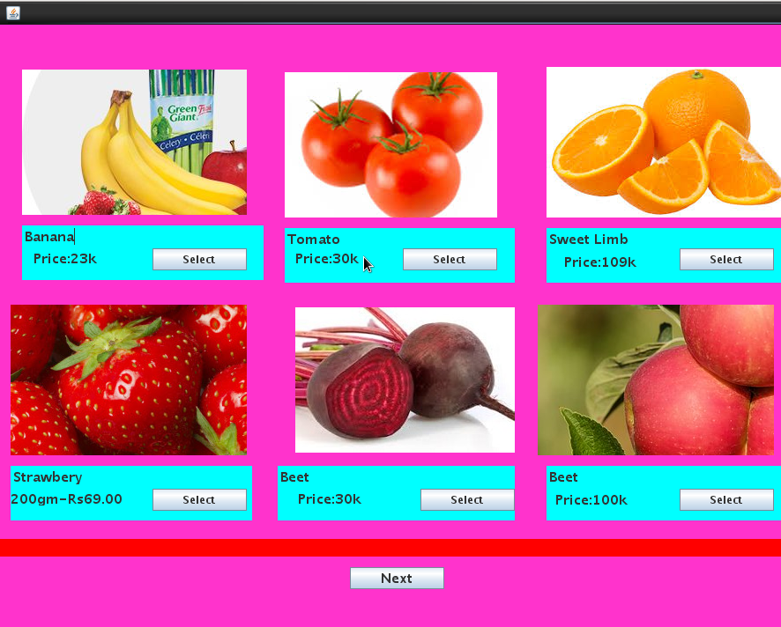

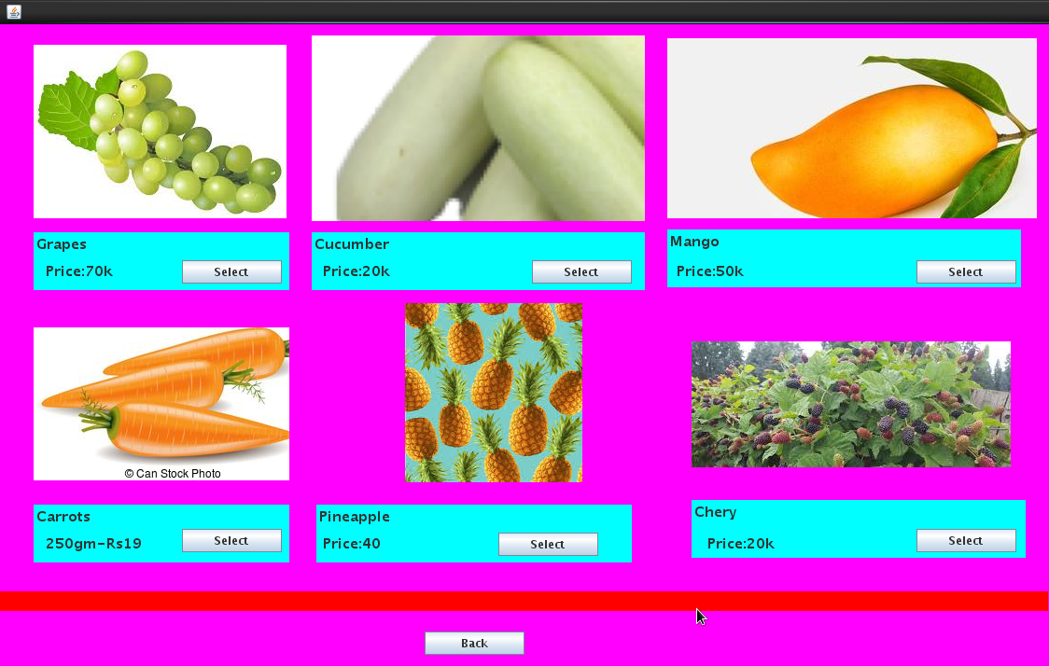

**Vegetables Information:**

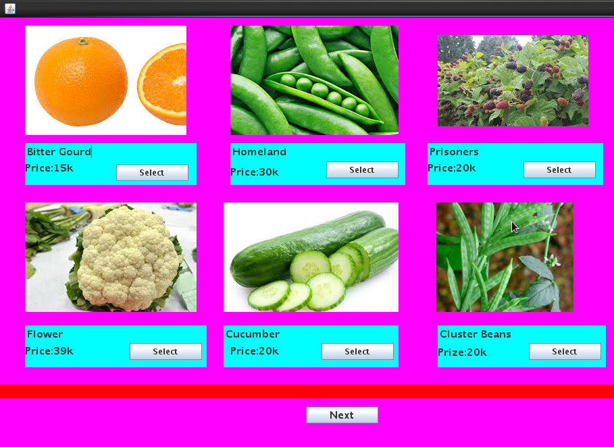

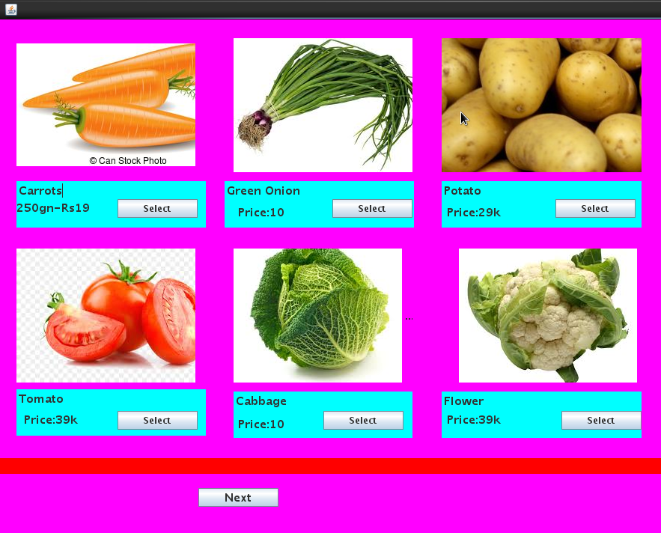

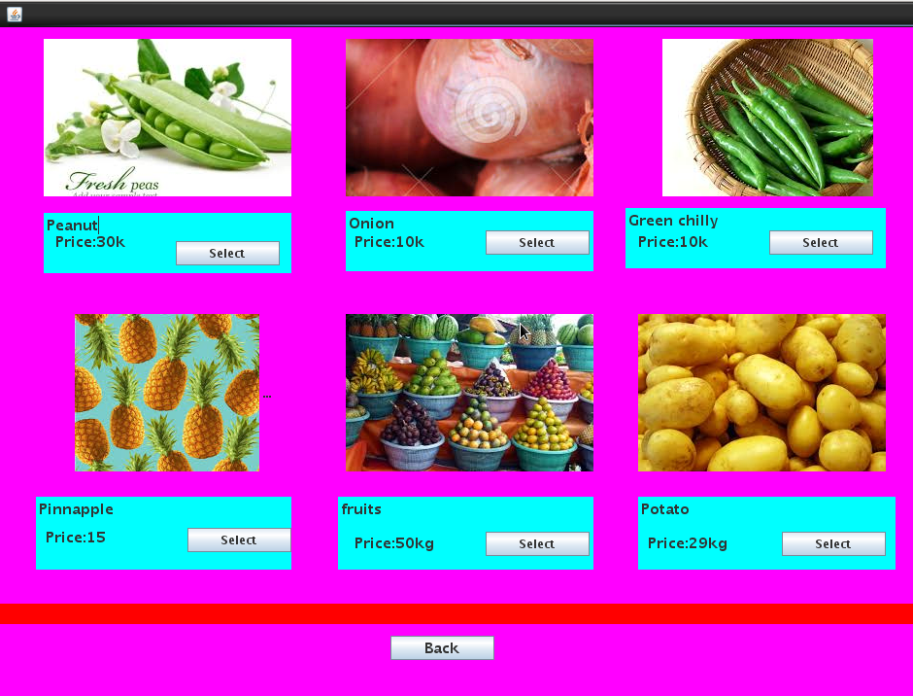

**Selected Item Information:**

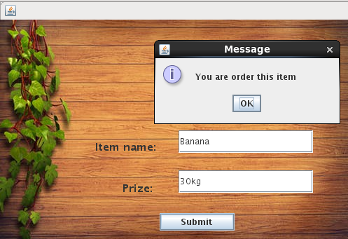

**Peraonal Information:**

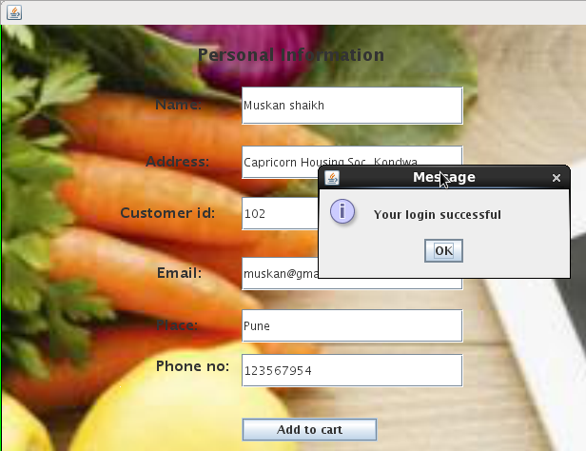

**Card Information:**

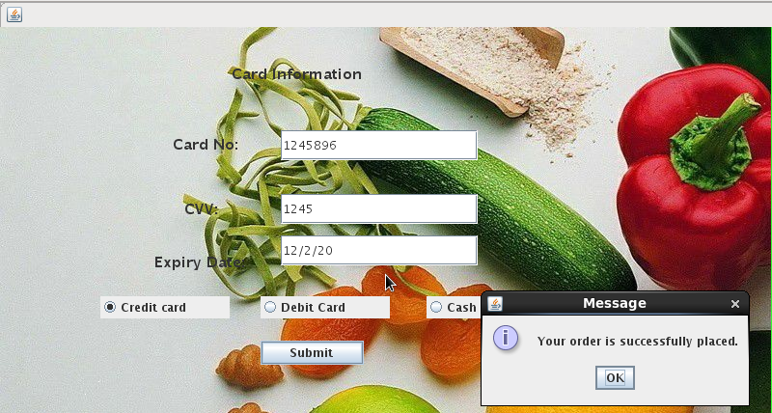

**Add Category Information:**

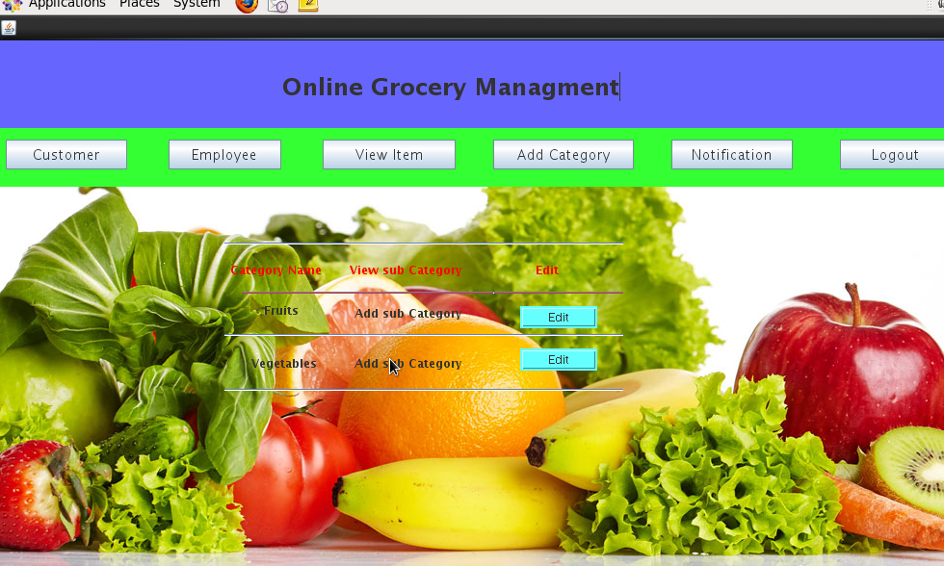

**Notification:**

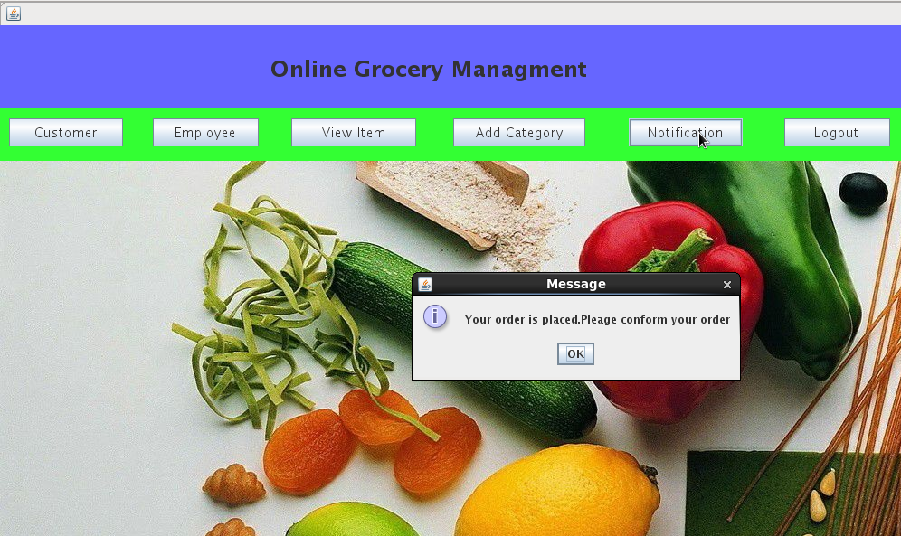

**Logout:**

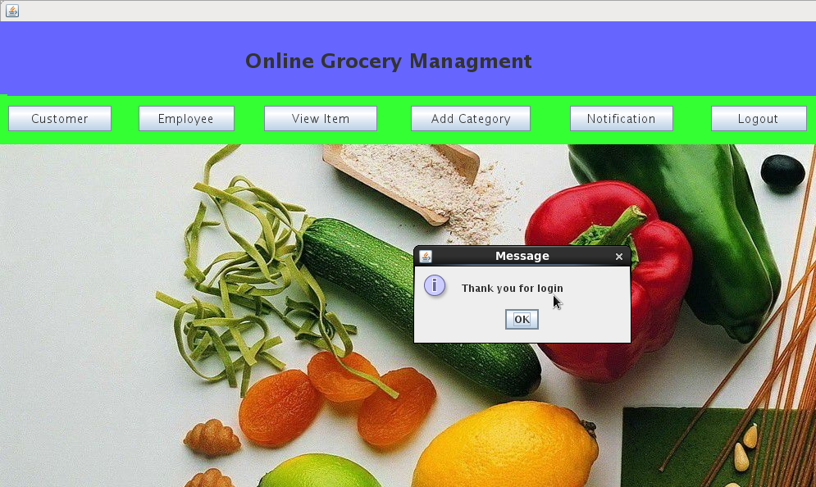

**Thanks form:**

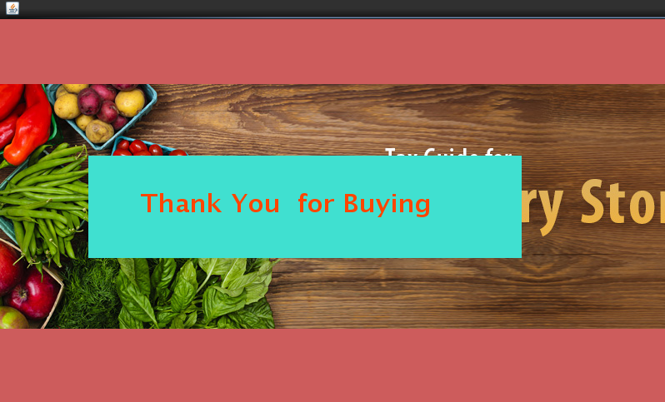

**SYSTEM CONFIGURATIONS**

**Hardware Requirements:**

* Processor Intel core2 dual
* 80GB Hard Disk
* 512MB RAM

**Software Requirements:**

* Operating System: Windows XP or above
* Front end: JAVA
* Back end : Postgresql
* JDK: JDK 1.6

**FUTURE ENHANCEMENT**

* We will develop our software for grocery management system.
* We will generate reports for all applicable features.
* We will make our project more users friendly.
* System record the grocery details in the systematic way.

**CONCLUSION**

* By implementing this grocery management system we are getting the more flexibility for the user.
* Which can operate from the home itself by implementing the pay and pickup and pay now options.

**BIBLIOGRAPHY:**

Books:

* Complete reference java2 by Herbert Schildt.
* Java2 Black book by Steven Holzner.
* Complete reference SQL by Groff Weinburg.
* JDBC and JAVA by George Reese.
* Unified Modelling Language user guide by Giant Dino
* [WWW.google.com](http://WWW.google.com)
* [WWW.umldiagram.org](http://WWW.umldiagram.org)